LABOUR MARKET SIGNALLING IN AGRICULTURE
MODEL AND DATA SETS
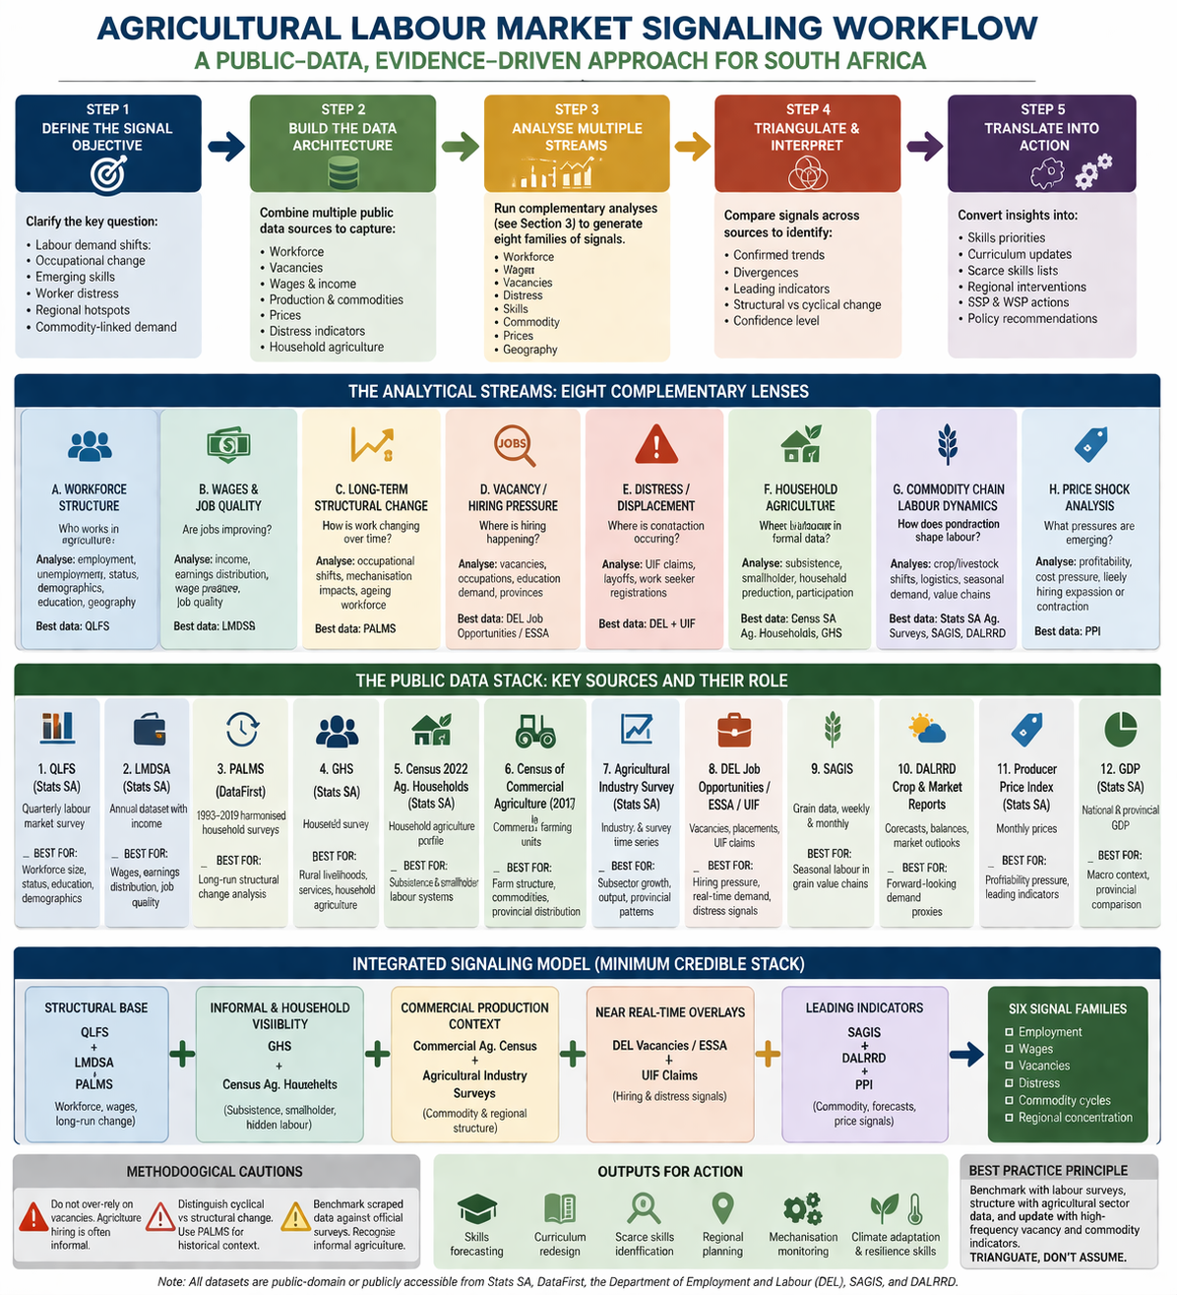

Methodology Note (Agriculture)
Developing Credible Labour Market Signals for South Africa’s Agricultural Industry
A triangulated analytical framework using public-domain datasets
1. Purpose of the methodology note
This note provides a rigorous methodological framework for developing credible labour market signals in South Africa’s agricultural industry using publicly available datasets. It draws on the most credible scholarship in labour market signalling, skills anticipation, labour market information systems (LMIS), and workforce forecasting.
The objective is to identify how evidence can be generated regarding:
- changing labour demand,
- emerging occupational needs,
- evolving skill requirements,
- worker displacement risks,
- regional hiring pressures,
- commodity-linked employment dynamics, and
- structural shifts in agricultural work.
The framework is designed for use in:
- Sector Skills Plans (SSPs),
- Workplace Skills Plans (WSPs),
- SETA intelligence systems,
- labour market observatories,
- agricultural workforce planning,
- TVET curriculum alignment,
- occupational qualification design, and
- regional rural development planning.

2. Conceptual foundation: what labour market signals are
2.1 Labour market signalling in scholarship
The foundational economics literature on signalling begins with Michael Spence’s work, where signals are observable indicators used under uncertainty to infer hidden productivity characteristics.
In modern labour market intelligence, the same principle is applied at sector level.
Because employers’ future labour needs cannot be directly observed in real time, analysts infer demand using observable proxies such as:
- vacancies
- wages
- hiring trends
- separations
- unemployment claims
- production shifts
- price movements
- output forecasts
- occupational transitions
- business confidence
- commodity cycles
These proxies become “signals”.

2.2 Important methodological warning from scholarship
OECD, ILO and CEDEFOP scholarship strongly cautions:
No single indicator is sufficient.
Reliable labour market intelligence requires triangulation across multiple evidence streams.
This matters especially in South African agriculture because:
- much hiring is informal
- seasonal work is common
- labour brokers mediate recruitment
- family labour is significant
- subsistence farming matters
- smallholder production is substantial
- online vacancies underrepresent reality
Therefore vacancy scraping alone is inadequate.

3. Core methodological approach
3.1 Analytical principle
The recommended methodology is:
Triangulated labour market signalling
This means combining:
- Workforce data
- Vacancy/opportunity data
- Wage/income data
- Commodity/output data
- Household agricultural activity
- Commercial farm structure
- Price movements
- Distress/displacement indicators

3.2 Sequential process

Step 1: Define the signal objective
Before analysis begins, specify exactly what is being measured.
Possible analytical questions include:
Labour demand
- Is employment growing or shrinking?
Occupational restructuring
- Are job roles changing due to mechanisation or digitalisation?
Skills emergence
- Are new competencies being requested?
Worker distress
- Are layoffs increasing?
Regional hotspots
- Which provinces show labour pressure?
Commodity-linked demand
- Which subsectors are expanding?

Step 2: Build dataset architecture
Use multiple public-domain sources.
The strongest South African stack includes:
- QLFS
- LMDSA
- PALMS
- GHS
- Census Agricultural Households
- Census Commercial Agriculture
- Agricultural Industry Surveys
- DEL Job Opportunities / ESSA / UIF
- SAGIS
- DALRRD crop forecasts
- Producer Price Index
- GDP agriculture series

Step 3: Conduct multiple analytical streams

A. Workforce structure analysis
Purpose:
Understand who currently works in agriculture.
Analyse:
- employment levels
- unemployment
- self-employment
- unpaid family labour
- demographics
- education
- geography
- formal vs informal work
Best dataset:
QLFS

B. Wage and job quality analysis
Purpose:
Assess whether jobs are improving.
Analyse:
- income
- earnings distribution
- wage pressure
- quality of employment
Best dataset:
LMDSA

C. Long-term structural change analysis
Purpose:
Identify historical transitions.
Analyse:
- mechanisation impacts
- ageing workforce
- declining labour intensity
- occupational shifts
Best dataset:
PALMS

D. Vacancy / hiring pressure analysis
Purpose:
Measure active recruitment.
Analyse:
- vacancies
- occupations recruited
- education demanded
- province of hiring
Best dataset:
DEL Job Opportunities / ESSA

E. Distress / displacement analysis
Purpose:
Detect contraction.
Analyse:
- UIF claims
- layoffs
- work seeker registrations
Best dataset:
DEL + UIF

F. Household agriculture analysis
Purpose:
Capture labour markets invisible to formal surveys.
Analyse:
- subsistence farming
- smallholder participation
- household production
Best datasets:
- Census Agricultural Households
- GHS

G. Commodity chain labour analysis
Purpose:
Link labour demand to production systems.
Analyse:
- crop expansion
- livestock shifts
- horticulture growth
- grain logistics
Best datasets:
- Stats SA agricultural industry
- SAGIS
- DALRRD

H. Price shock analysis
Purpose:
Detect leading indicators.
Analyse:
- commodity profitability
- cost pressure
- likely hiring expansion or contraction
Best dataset:
Producer Price Index

4. Public-domain datasets and their methodological use

4.1 Quarterly Labour Force Survey (QLFS)
Source:
Stats SA / DataFirst
Measures:
- employment
- unemployment
- occupation
- education
- demographics
Best methodological use:
Baseline agricultural workforce profiling.

4.2 Labour Market Dynamics in South Africa (LMDSA)
Source:
Stats SA
Measures:
- annual earnings
- income
Best use:
Wage signal analysis.

4.3 PALMS
Source:
DataFirst
Measures:
Long-term labour market history.
Best use:
Structural transformation analysis.

4.4 General Household Survey
Best use:
Rural livelihoods and household agriculture.

4.5 Census Agricultural Households
Best use:
Subsistence and smallholder labour systems.

4.6 Census Commercial Agriculture
Best use:
Commercial farming structure.

4.7 Agricultural Industry Survey
Best use:
Subsector growth patterns.

4.8 DEL Job Opportunities / ESSA
Best use:
Near real-time hiring signals.

4.9 SAGIS
Best use:
Grain chain seasonal labour demand.

4.10 DALRRD crop forecasts
Best use:
Forward-looking employment proxies.

4.11 Producer Price Index
Best use:
Profitability pressure.

5. Recommended integrated signalling model
Minimum credible evidence stack
A robust agricultural labour market intelligence system should combine:
Structural base
- QLFS
- LMDSA
- PALMS
Informal / household visibility
- GHS
- Agricultural households census
Commercial production context
- Commercial agriculture census
- Agricultural industry surveys
Near real-time overlays
- DEL vacancies
- UIF claims
- ESSA
Leading indicators
- SAGIS
- DALRRD
- PPI

6. Practical application for SETAs and SSP development
This methodology can support:
Skills forecasting
Identify likely future occupations.
Curriculum redesign
Align qualifications with emerging needs.
Scarce skills identification
Improve SSP evidence quality.
Regional planning
Target provinces with strongest labour shifts.
Mechanisation monitoring
Track occupational disruption.
Climate adaptation skills
Detect resilience-related labour needs.

7. Methodological cautions
7.1 Do not over-rely on vacancies
Agricultural hiring is often informal.
7.2 Distinguish cyclical vs structural change
Use PALMS for historical context.
7.3 Benchmark scraped data
Against official surveys.
7.4 Recognise informal agriculture
Household production matters greatly.

8. Final methodological conclusion
The most credible way to develop labour market signals in South Africa’s agricultural industry is not to rely on a single data source.
It is to build a triangulated intelligence architecture that combines:
- labour force surveys
- wage data
- historical trends
- household agriculture
- commercial farm structure
- vacancies
- unemployment claims
- commodity production
- market forecasts
- price signals
In methodological terms:
Benchmark with labour surveys, structure with agricultural sector data, and update with high-frequency vacancy and commodity indicators.
That is the strongest public-domain approach currently available for credible agricultural labour market signalling in South Africa.

9. Key public access links
Stats SA
https://www.statssa.gov.za/
DataFirst
https://www.datafirst.uct.ac.za/
DEL Labour Market Information
https://www.labour.gov.za/
SAGIS
https://www.sagis.org.za/
DALRRD
https://www.dalrrd.gov.za/

If useful, I can also convert this into:
- an SSP-ready formal policy note
- a SETA training handout
- a PowerPoint methodology diagram
- a labour market signalling framework graphic
- an agricultural skills forecasting workflow for AI-assisted analysis

A credible labour-market-signalling approach for South African agriculture should start from a simple premise: signals are imperfect proxies, not direct observations of skill demand. In the classic signalling literature, employers infer productivity from observable markers under uncertainty; in modern labour-market intelligence, that logic is extended from individual credentials to wider market indicators such as vacancies, wages, separations, output changes, prices, and occupational shifts. The strongest contemporary OECD/ILO line is that no single method is sufficient for skills anticipation; reliable inference comes from triangulating administrative, survey, vacancy, and sectoral production data. (Simon Fraser University)
For agriculture, that point matters even more than in many other sectors. Online vacancy data underrepresent parts of the labour market, and Cedefop’s methodological work shows that online job-ad data have coverage biases by occupation, sector and geography; they are useful, but not a complete measure of vacancies. In South Africa, this is especially relevant because a large share of agricultural work is seasonal, rural, informal, household-based, or recruited through local networks rather than formal online adverts. Stats SA’s Census 2022 agricultural-household work confirms the importance of household-level agricultural activity for food security, job creation and rural development, and explicitly notes that the data are used to build a frame for smallholder and subsistence agriculture. (CEDEFOP)
So, in practice, the process should look like this.
1. Define the signal target clearly.
Decide whether you are trying to detect:
- short-run labour demand shifts,
- medium-run occupational restructuring,
- emerging skill bundles,
- regional/commodity-specific hiring pressure,
- or worker distress/displacement.
Those are different phenomena and require different indicators. ILO guidance on labour-market information and skills anticipation is explicit that labour-market information systems work best when indicators are purpose-built rather than treated as a generic dashboard. (International Labour Organization)
2. Build a multi-source indicator architecture.
For agriculture, the most credible architecture is to combine:
- household labour data for employment, informality, hours, education, demographics, and provincial/farm-area patterns;
- vacancy/opportunity data for immediate hiring signals and requested qualifications;
- sector output and structure data for commodity, province and farm-type demand contexts;
- price and production data for leading indicators of future hiring pressure or contraction;
- long-run harmonised microdata to identify structural rather than cyclical change.
This is the same broad logic recommended in OECD and ILO skills-anticipation work: triangulate demand-side and supply-side evidence, and test one signal against another. (OECD)
3. Do several distinct analyses, not one.
The main analysis types are:
A. Descriptive labour-market structure analysis
Measure who works in agriculture, where, under what employment status, with what education profile, hours, and demographic composition. This tells you the current workforce base and where replacement demand is likely to arise. QLFS is central here because it is Stats SA’s official labour-market survey and includes employment/unemployment information. (Statistics South Africa)
B. Trend analysis over time
Track changes in agricultural employment, self-employment, unpaid family work, formality, age composition, and province/metro/rural distribution. PALMS is particularly useful here because it harmonises 69 household surveys from 1993–2019, making long-run structural analysis possible. (Data Catalog)
C. Vacancy and opportunity analysis
Use official job-opportunity data to detect occupations, education levels, provinces and industries where hiring pressure is visible. South Africa’s Department of Employment and Labour uses vacancy data and UIF claims together in its Job Opportunities and Unemployment reports, and the LMIS Master Plan explicitly includes weekly job opportunities through ESSA plus vacancies by occupation, industry and province.
D. Skill-content / task-content analysis
Where vacancy text exists, code adverts into skill clusters: machinery operation, irrigation, precision agriculture, livestock management, quality assurance, food safety, traceability, pesticide handling, logistics, cold-chain work, supervisory skills, digital recordkeeping, compliance, and maintenance. The scholarship on online labour-market data supports this, but also stresses representativeness checks before treating job-ad counts as population truth. (CEDEFOP)
E. Commodity-chain linked demand analysis
Link labour indicators to production, planted area, output mix, commodity prices, trade flows and seasonality. In agriculture, labour demand is often derived demand: it moves with output, crop mix, mechanisation and weather exposure rather than with a stand-alone “jobs market.” Stats SA’s agricultural industry and commercial-agriculture datasets, together with SAGIS grain data and DALRRD crop/market releases, are valuable here.
F. Distress / displacement analysis
Use UIF claims, work-seeker registrations, and reductions in output or price margins to detect contraction, not just growth. DEL’s JOI reports explicitly combine demand-side vacancy analysis with UIF claims on the supply side.
G. Geographic hotspot analysis
Map labour signals by province, district or farming region. Agriculture is spatially uneven; national averages hide a lot. Census of Commercial Agriculture and provincial agricultural statistics are useful for this. (Statistics South Africa)
The datasets below are the strongest public-domain or public-access sources for building credible agricultural labour-market signals in South Africa.
1) Quarterly Labour Force Survey (QLFS) — Stats SA / public-use microdata
What it is: Stats SA’s official household-based labour-market survey for people aged 15+; public-use microdata are distributed through DataFirst/World Bank Microdata Library. (Statistics South Africa)
Why it matters for agriculture:
Best source for current agricultural employment, unemployment, labour-force participation, status in employment, education, geography, and many worker descriptors. It is indispensable for seeing whether agricultural labour demand is being met through wage employment, self-employment, or unpaid household work. (World Bank Microdata)
Best uses:
Quarterly trend monitoring; province/rural-urban comparisons; demographic and educational profiling; linking agriculture to broader labour-market tightening or slack. (World Bank Microdata)
Important limitation:
The QLFS public microdata after 2010 generally do not include quarterly income, because Stats SA instead provides income in the annual LMDSA file. (World Bank Microdata)
2) Labour Market Dynamics in South Africa (LMDSA) — Stats SA / DataFirst public-use microdata
What it is: Annual dataset built from the four QLFS waves in a year, including variables such as income that are not available in the standard quarterly files. (World Bank Microdata)
Why it matters for agriculture:
Best official public source for analysing annual earnings, employment status and labour transitions in agriculture. Helpful for wage-signal analysis and for distinguishing “more jobs” from “better jobs.” (World Bank Microdata)
Best uses:
Annual wage trends; income distribution of agricultural workers; occupation-by-earnings analysis; province-by-earnings comparisons. (World Bank Microdata)
3) Post-Apartheid Labour Market Series (PALMS) — DataFirst public-use harmonised series
What it is: A harmonised stacked cross-section of 69 South African household surveys from 1993–2019. (Data Catalog)
Why it matters for agriculture:
The best single source for long-run structural analysis of agricultural employment, occupational change, and earnings trends. It lets you separate a temporary shock from a decades-long shift. (Data Catalog)
Best uses:
Long-run change in agricultural employment share; mechanisation-era restructuring; ageing of the agricultural workforce; historical provincial shifts; labour-market polarisation. (Data Catalog)
Caution:
Because PALMS harmonises multiple surveys, users need to understand weights and comparability rules; the documentation explicitly discusses weighting choices for time-series consistency. (Data Catalog)
4) General Household Survey (GHS) — Stats SA / public-use microdata
What it is: Long-running household survey covering basic services, education, health and agriculture, with public-use access through DataFirst/World Bank Microdata Library. (Statistics South Africa)
Why it matters for agriculture:
It is useful for signals that sit around the labour market rather than inside it: household agricultural participation, subsistence/smallholder activity, service access, and rural constraints that shape labour supply and productivity. (Statistics South Africa)
Best uses:
Smallholder and subsistence participation; household production involvement; rural vulnerability; identifying where labour-market signals are likely to be weak in online or employer datasets. (Statistics South Africa)
5) Census 2022 Agricultural Households — Stats SA
What it is: Census-based profile of households’ involvement in agriculture, including main activity, livestock/poultry holdings, purpose of activity, and place/size of activity.
Why it matters for agriculture:
This is crucial for understanding the non-commercial and household side of agriculture, which conventional vacancy datasets miss. It is especially useful for identifying latent labour demand, household production systems, and regional participation patterns.
Best uses:
Mapping household agriculture; separating commercial from subsistence dynamics; identifying regions where skilling demand may be for extension, productivity, or transition support rather than formal recruitment.
6) Census of Commercial Agriculture 2017 + provincial commercial agriculture tables — Stats SA
What it is: Detailed census of commercial farming units, with downloadable provincial statistics and time-series files in Excel/ASCII on the Stats SA site. (Statistics South Africa)
Why it matters for agriculture:
Best structural dataset on the commercial farming side: farm types, production patterns, provincial distribution, and sector structure. This is essential context for labour-demand inference by commodity and region. (Statistics South Africa)
Best uses:
Commodity-region mapping; estimating where supervisory, technical, animal-health, horticulture, irrigation or machinery skills are most likely to be demanded; identifying concentration patterns. (Statistics South Africa)
7) Agricultural Industry / Agricultural Survey time series — Stats SA
What it is: Current agricultural industry publication plus downloadable agricultural-survey and agricultural-industry time-series files. Stats SA’s 2023 agricultural industry report shows total income, subsector shares and provincial contributions, and the time-series page provides Excel/ASCII files for agricultural industry and agricultural survey releases.
Why it matters for agriculture:
These are strong leading-context datasets. Where income, output or subsector shares are rising, labour demand often shifts shortly after, though not always one-for-one because mechanisation can decouple output from jobs.
Best uses:
Subsector demand inference; livestock vs horticulture vs mixed-farming shifts; provincial growth hotspots; identifying where skills demand may tilt toward management, services or mechanised operations.
8) Department of Employment and Labour Job Opportunities / ESSA / UIF reports
What it is: DEL’s annual Job Opportunities and Unemployment reports analyse vacancy data and combine them with UIF claims; the LMIS Master Plan also sets out vacancy indicators by occupation, industry and province, as well as ESSA job opportunities and placements.
Why it matters for agriculture:
This is the strongest official source for near-real-time labour-demand and labour-distress signals from the state side. Even when agriculture-specific sample sizes are modest, the architecture is valuable and can be extracted by industry/province where available.
Best uses:
Hiring-pressure indicators; education requirements in vacancies; provincial recruitment patterns; matching demand-side vacancies to supply-side unemployment or claims.
9) SAGIS grain and oilseed data
What it is: South African Grain Information Service publishes weekly and monthly data, product data, import tariffs, parity prices and bulletins. (Sagis)
Why it matters for agriculture:
For grain and oilseed value chains, this is one of the best high-frequency operational datasets. It does not measure labour directly, but it is a strong leading indicator for logistics, storage, milling, grading, and seasonal operational labour demand. (Sagis)
Best uses:
Seasonality modelling; harvest-related labour needs; storage and handling demand; linking commodity cycles to occupation demand in grain ecosystems. (Sagis)
10) DALRRD crop estimates, crops-and-markets, and economic-overview publications
What they are: Public reports from DALRRD covering crop estimates and forecasts, supply-demand balances, markets, and quarterly agricultural economic overviews. (USDA)
Why they matter for agriculture:
They are useful as leading context signals. Output forecasts, crop balances and market conditions often move before formal employment data do. That makes them valuable in building predictive signals for commodity-specific labour demand. (USDA)
Best uses:
Forecast-led labour-demand proxies; identifying likely demand spikes in planting, harvesting, animal production, logistics and agro-processing interfaces. (USDA)
11) Producer Price Index (PPI) for agriculture, forestry and fishing — Stats SA
What it is: Monthly producer-price statistics including agriculture, forestry and fishing. (Statistics South Africa)
Why it matters for agriculture:
Price signals are not labour signals, but they are often early indicators of margin pressure, expansion incentives, or contraction risks. Persistent price shifts can foreshadow changes in hiring, subcontracting, and mechanisation choices. (Statistics South Africa)
Best uses:
Leading indicators of labour distress or expansion; commodity margin pressure; linking price shocks to wage or hours adjustments. (Statistics South Africa)
12) GDP / provincial GDP agriculture series — Stats SA
What it is: National and provincial GDP releases with agriculture, forestry and fishing contributions, plus provincial GDP tables. (Statistics South Africa)
Why it matters for agriculture:
Useful for macro context and provincial comparison, though too aggregated for direct skills inference. Stronger as a contextual series than as a primary labour signal. (Statistics South Africa)

What a credible agricultural signalling model would combine
For South Africa’s agricultural industry, I would treat the following as the minimum credible stack:
- QLFS / LMDSA for current workforce structure, employment status and earnings. (World Bank Microdata)
- PALMS for long-run structural change. (Data Catalog)
- DEL vacancy + UIF/ESSA data for immediate hiring and distress signals.
- Commercial agriculture + agricultural industry data for commodity and provincial structure.
- Census 2022 agricultural households + GHS to capture smallholder, subsistence and household agriculture that formal labour datasets miss.
- SAGIS + DALRRD crop/market data + PPI as leading indicators. (Sagis)
That combination lets you produce at least six robust signal families:
employment level signals, wage signals, vacancy signals, distress signals, commodity-cycle signals, and regional concentration signals. (International Labour Organization)
The main caution
The biggest methodological risk is to treat online or formal vacancy data as “the labour market.” The scholarship does not support that. Online-job-ad data are valuable for skill extraction and timeliness, but they need benchmarking against labour-force and vacancy surveys because representativeness is uneven. In South African agriculture, that caution is stronger than usual because of informality, seasonality, labour brokers, household production, and local/offline recruitment channels. (CEDEFOP)
Best practical conclusion
For the agricultural industry, the most defensible approach is not “scrape job ads and infer skills.” It is:
benchmark with QLFS/LMDSA and PALMS, structure with commercial-agriculture and household-agriculture data, then use vacancy/ESSA/UIF and commodity/price data as high-frequency overlays. That is the closest thing to a credible labour-market signalling architecture available from public South African data. (World Bank Microdata)
I can turn this into a sector-methodology note with a table of each dataset, variables, update frequency, access route, and recommended analytic use for agriculture.

